Counts

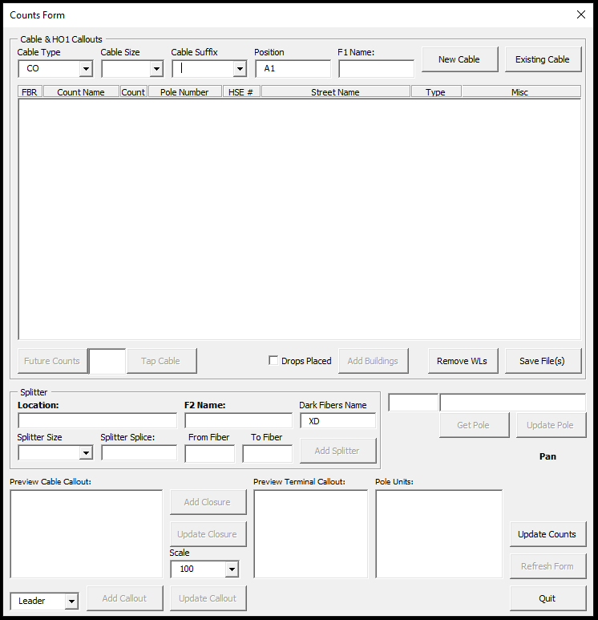

From when this form opens until you click Quit, you are placing counts on one cable.

You will need to stop at the end of the cable or at a pole with no splicing proposed yet. The cable counts that are saved in the pole block are for the back span. If you drop off spare fibers down a tap cable or place a future cable with counts, any unused fibers will continue down the main cable if you stop at the tap pole instead of moving to the next and saving.

**Adding a New Cable**: Change Cable Type and Position, if necessary, add the Cable Size and F1 name, and add a Cable Suffix if needed before clicking on New Cable. After Clicking on New Cable, the New Cable form pops up. Complete the counts by filling out the Type, From Fiber, To Fiber, and Start Count. The form will check if the fiber color matched the count color, and will fill out the End Count based on the number of Fibers allocated. When the counts are complete, click Done. The form will hide and you are prompted to select the structure to attach the cable and the previous structure toward the C.O.

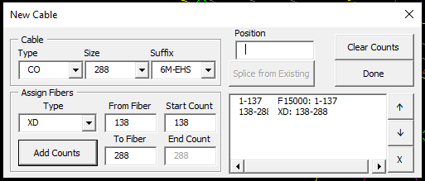

Once the cable is attached to a structure, the Counts form reappears with the Counts listbox filled out and the structure name shown above Get Pole and Update Pole.

**Getting an Existing Cable**: Click on Existing Cable and the form will disappear. You will be prompted to select a structure with a cable already attached. Once selected, the form will reappear with the Counts listbox filled out and the structure name shown above Get Pole and Update Pole.

**Adding a Tap Cable**: Select the last fiber being splice in the Counts listbox and enter the number of fibers spliced in the textbox between Future Counts and Tap Cable.

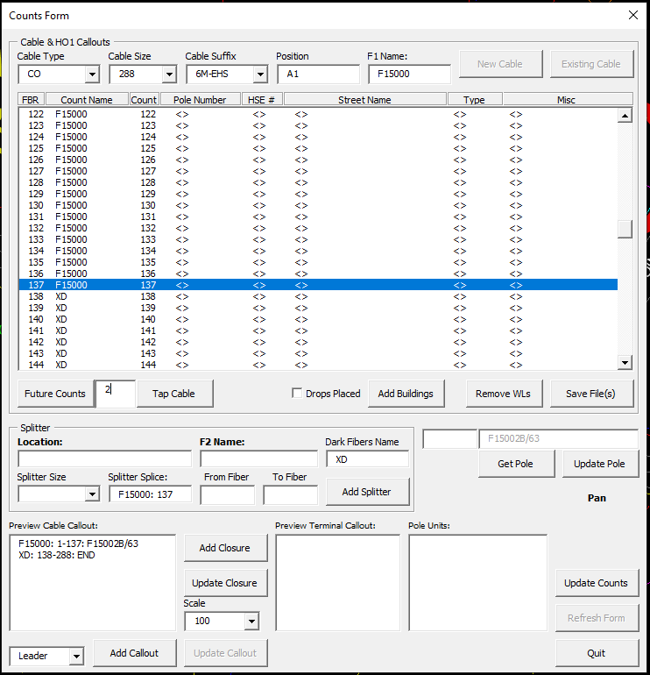

Once you click on Tap Cable the form will disappear and the New Cable form will appear. It will be filled out with the Counts put on the lowest fibers on color and size the cable to be the smallest able to carry the counts. Change the size and counts if necessary. Once the cable is correct, click Done and the form will disappear and you will be prompted to select the first structure on the tap route. Once selected, the Counts form will reappear with the listbox updated with the tap fibers allocated.

**Add Splitter**:

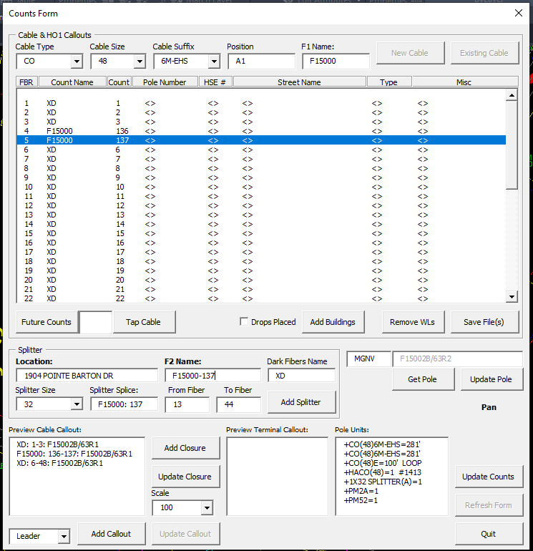

Select the F1 fiber in the listbox. Enter the splitter Location or click on Location: and select the customer to add the address in the textbox. Select the Splitter Size. It will auto fill From Fiber and To Fiber based on the cable size and splitter size. These can be changed manually. Once these fields are filled out, click on Add Splitter. The form will disappear and you will be prompted to select the closure for the splitter. This will add the Splitter block to the drawing with the splitter name. The form will reappear with the counts updated in the counts listbox.

**Do not end at a splitter structure after adding a splitter.** Either end at the structure before adding the splitter, or after creating the splitter, add taps and buildings, then get the next structure.

**Add Buildings**:

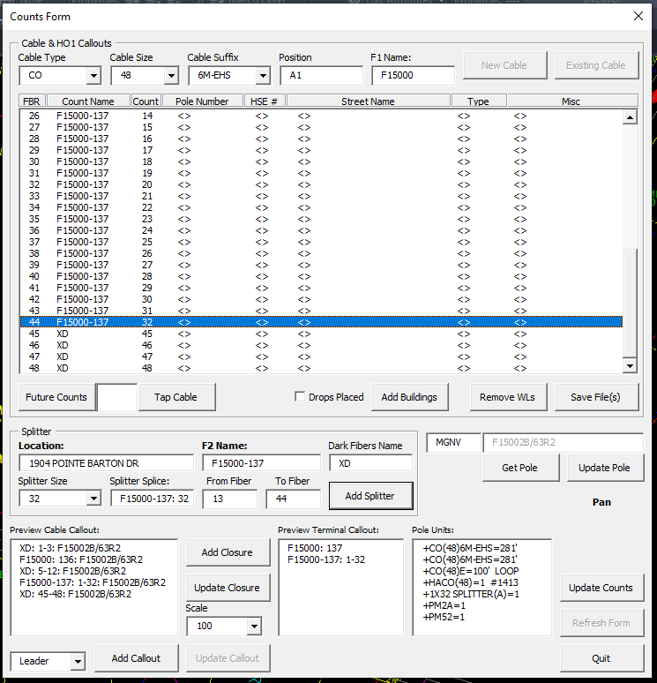

First, select the count you want to start with in the listbox. When you click on Add Buildings, the form will disappear and you can start selecting Customer and SG blocks. When you are done, right click on the screen or select something other than a block.

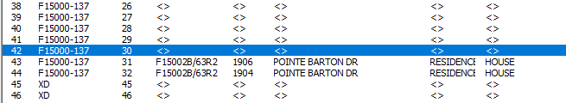

**Save File(s)**: To save the counts to a file click on Save File(s).

**Update Pole**: To save the counts spliced at a structure click on Update Pole.

**Get Pole**: To move to the next structure, click on Get Pole. It can be a pole, HH, or ped. It will update the counts spliced on the previous structure add the cable and counts to the structure.